UNIT 3
PART – A
1.For the given IPv4 address: 11000001 10000011 00011011 11111111, the equivalent dotted decimal notation is
- 193.131.26.255
- 193.130.27.255
- 193.131.27.255
- 193.130.26.255
ANSWER: C

2.Identify the class of the given IPv4 address: 252.5.15.111
- Class A
- Class D
- Class C
- Class E
ANSWER: D

3.The equivalent hexadecimal notation for the given IPv4 address 11000001 10000011 00011011 11111111 is
- C1831BFF₁₆
- C1830BFF₁₆
- C1831AFF₁₆
- C1831BEF₁₆
ANSWER: A

4.The addresses hold by Class C in address space of IPv4 is
- 50%
- 25%
- 12.5%
- 6.25%
ANSWER: C

5.Which of the following is correct regarding Class B Address of IP address
A. Network bit –16, Host bit –16
B. Network bit –16, Host bit –14
C. Network bit –18, Host bit –16
D. Network bit –12, Host bit –14
Answer A. Network bit – 16, Host bit 16

6.What is the default mask for a class C Network?
A. 255.255.255.1
B. 255.255.255.0
C. 255.255.255.254
D. 255.255.255.255
Answer B. 255.255.255.0

7.Value of TOS bits is 0100 in IPv4 packet. what is the type of service provided?
A. Minimize cost
B. Maximize reliability
C. Maximize Throughput
.D. Minimize delay
Answer C. Maximize throughput

8.The address space of IPv6 is ________ addresses.
- 2⁹⁶
- 2³²
- 2¹²⁸
- 2¹²⁴
ANSWER: C

9.Which among the following features is present in IPv6 but not in IPv4?
a) Fragmentation
b) Header checksum
c) Options
d) Anycast address
ANSWER: D

10.The field in IPv6 which serves as TTL in IPv4 is
- Flow label
- Priority
- Payload length
- Hop limit
ANSWER: D

11.In distance vector routing, each node shares its routing table with its -------- periodically.
- Immediate neighbours
- All neighbours
- Few neighbours
- No neighbours
ANSWER: A

12.Identify the interdomain routing protocol that uses path vector routing.
A. Link protocol
B. Border Gateway Protocol
C. Routing Information Protocol
D. OSPF
ANSWER: B

13.In _______ forwarding, the destination address is a network address in the routing table.
A) next-hop
B) network-specific
C) host-specific
D) default
Answer :B

14.Ipv4 is ---------------- datagram protocol.
- A Reliable and connectionless
- An Unreliable and connection-oriented
- An Unreliable and connectionless
- A Reliable and connection-oriented
ANSWER: C

15.In DVR, the periodic update of the routing table normally occurs every -------.
- 10 seconds
- 20 seconds
- 30 seconds
- 60 seconds
ANSWER: C

16.The following is not a solution for instability (count to infinity) problem in DVR.
- Defining the infinity
- Split Horizon
- Bit stuffing and unstuffing
- Split Horizon and poison reverse
ANSWER: C

17.Count-to-infinity problem occur in _______________
A. DVR
B. LSR
C. BGP
D. Hierarchical Routing
Answer: A

18.In OSPF, a ………. link is a network is connected to only one router.
A. point-to-point
B. transient
C. stub
D. multipoint
Answer: c

19.A block of addresses is granted to a small organization. We know that one of the addresses is 205.16.37.39/28. What is the first address in the block?
- 205.16.37.32
- 205.17.37.32
- 205.16.38.32
- 205.17.38.32
ANSWER: A

20.Consider the fragmentation process in IPv4, the original datagram which are numbered from 0 to 3999. The original datagram is fragmented into 3 fragments and those are numbered as 0 to 1399, 1400 to 2799 and 2800 to 3999 as first, second and third fragments respectively. The offset value for the first, second and third fragments are
- 0, 165, and 350
- 0, 175, and 350
- 0, 175, and 250
- 0, 165, and 250
ANSWER: B

21.In a block of addresses, we know the IP address of one host is 182.44.82.16/26. What is the first address in this block?
- 182.44.82.0
- 182.44.81.0
- 182.43.82.0
- 181.44.82.0
ANSWER: A

22.Find the number of addresses in a block of classless addresses if one of the address is 12.2.2.7/24
A. 16
B. 8
C. 256
D. 128
Answer C

23.In a block of addresses, we know the IP address of one host is 12.2.2.127/28. What is the last address in this block?
A. 12.2.2.16
B. 12.2.2.122
C. 12.2.2.128
D. 12.2.2.127
Answer D

24.An organization is granted a block; one address is 2.2.2.64/20. The organization needs 10 subnets. What is the subnet prefix length?
A) /20
B) /24
C) /25
D) /23
Answer B

25.What is the shortest path from node A to node F?
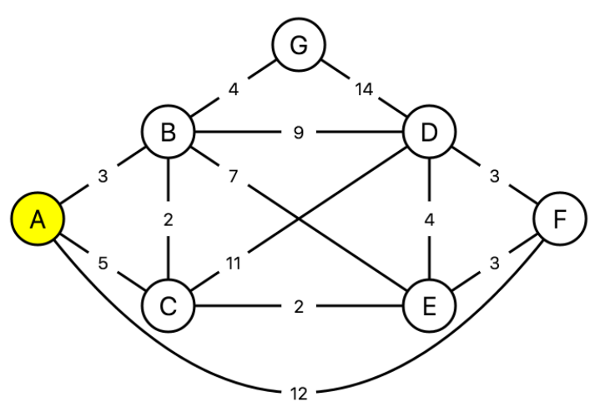
A. A -> B -> D -> F
B. A -> C -> B -> E -> F
C. A -> F
D. A -> C -> E -> F
Answer : D

Part B & C - QUESTION BANK
(Consists of 4Marks, 6Marks, 8 Marks and 12 Marks)
- Draw and explain the datagram of IPV4. (12 Marks)
- Draw and explain the IPv6 datagram format. (12 Marks)
- List out the advantages of IPV6 over IPV4? (4 Marks)
- For the given IP address 132.23.120.8, find the class, Net id and Host id and range of address? (4 Marks)
- Define the term Autonomous system and give its type of routing protocols? (4 Marks)
- Find the class of each address: (4 Marks)
- 252.5.15.111
- 14.23.125.8
- 11001010 01011101 11111111 01101011
- 01000000 10101111 10111011 11001100
- An IP packet has arrived with the first few hexadecimal digits as shown: 0x45 00 00 28 00 01 00 00 05 17……. Calculate the HLEN and total length values. How many hops can this packet travel before being dropped? The data belong to what upper layer protocol? (4 Marks)
- Consider the fragmentation process in IPv4, the original datagram which are numbered from 0 to 3999. The original datagram is fragmented into 3 fragments and those are numbered as 0 to 1399, 1400 to 2799 and 2800 to 3999 as first, second and third fragments respectively. Calculate the offset value for the first, second and third fragments. The second fragmented datagram is further fragmented into two fragments and each has numbered as 1400 to 2199 and 2200 to 2799. Calculate the offset values for these two fragmented datagrams too. The identification field for the original datagram is given as 14,567, what would be the identification field values for all the fragmented datagrams. (6 Marks)
- Consider the following network in DVR, show the updated routing table of D when it receives routing update from A for the first time. (12 Marks)
  - 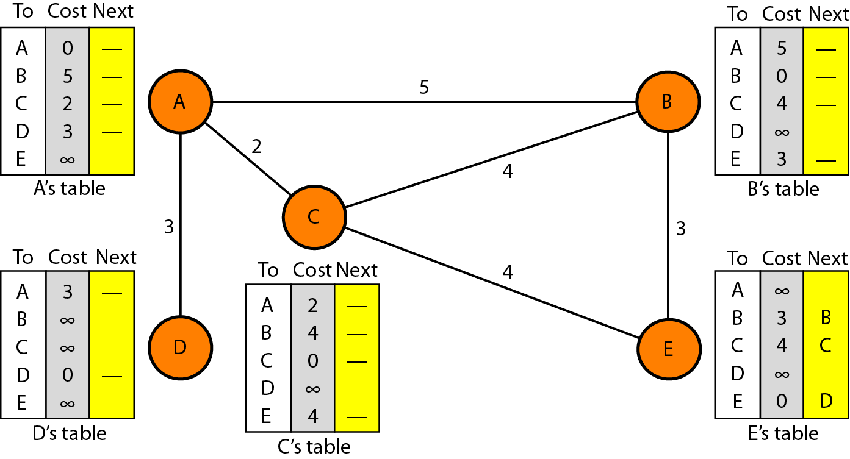

- In RIP, a routing table has 40 entries; it doesn’t receive information about 20 routes for 200 seconds. How many timers are running at this time? (4 Marks)
- For the given diagram, obtain (Distance Vector Routing). the node 'A’ and node 'E' final routing table using DVR with necessary steps. (12 Marks)

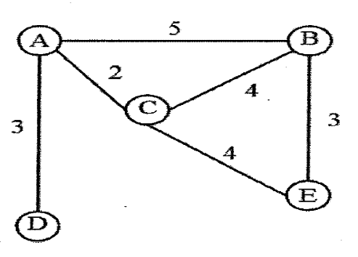

- Design and implement the Dijisktra algorithm and Find the shortest paths from the viewpoint of node A (12 Marks)

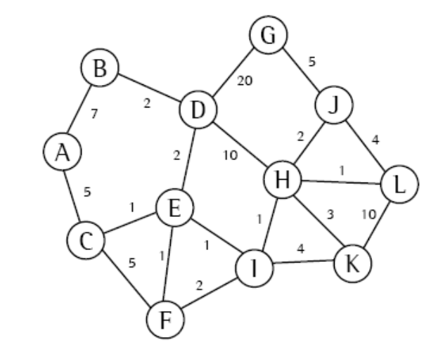
- Change the following IPv4 addresses from binary notation to hexadecimal notation. (4 Marks)
  - 10000001 00001011 00001011 11101111
  - 11000001 10000011 00011011 11111111

- Change the following IPv4 addresses from binary notation to dotted-decimal notation. (4 Marks)
  - 10000001 00001011 00001011 11101111
  - 11000001 10000011 00011011 11111111
  - 11100111 11011011 10001011 01101111
  - 11111001 10011011 11111011 00001111

- An address in a block is given as 73.22.17.25. Find the number of addresses in the block, the first address, and the last address. (4 Marks)

- An address in a block is given as 180.8.17.9. Find the number of addresses in the block, the first address, and the last address. (4 Marks)

- A router receives a packet with the destination address 201.24.67.32. Show how the router finds the network address of the packet. (4 Marks)

- A classless address is given as 167.199.170.82/27. Find the number of addresses in the block, the first address and the last address. (4 Marks)

- An organization is granted a block of addresses with the beginning address 14.24.74.0/24. The organization needs to have 3 subblocks of addresses to use in its three subnets: one subblock of 10 addresses, one subblock of 60 addresses, and one subblock of 120 addresses. Design the subblocks. (6 Marks)

- In classless addressing, what is the size of the block (N) if the value of the prefix length (n) is one of the following? (4 Marks)
  - a. n = 0 b. n = 14 c. n = 32

- In classless addressing, what is the value of the prefix length (n) if the size of the block (N) is one of the following? (4 Marks)
  - a. N = 1 b. N = 1024 c. N = 2³²

- List out the steps need to be followed to guarantee the proper operation of the subnetworks. (4 Marks)

- Write a short note on Loop back address and Limited broadcast address in IPv4. (6 Marks)

- Mention the special addresses in IPv4. (4 Marks)

- Show the shortest form of the following addresses. (4 Marks)
- 2340:1111:119A:A000:0000:0000:0000:0000
- 0000:0000:0000:2340:0000:0000:4444:0000

- Show the original (unabbreviated) form of the following addresses. (4 Marks)
- 0::0
- 1234::1:2

- What is NAT? How can NAT help in address depletion? (4 Marks)

- List the classes in Classful addressing and define the occupany of address space by each class? (4 Marks)

- What is a mask in IPv4 addressing? What are the default masks for Class A, B and C? (4 Marks)
- Explain why a medium size or large size corporation does not want a block of class C addresses? (4 Marks)

- What is meant by address space? List the address space for IPv4 and IPv6. (4 Marks)

- An IPv4 packet has arrived with the first 8 bits as (01000011)2 The receiver discards the packet. Why? (4 Marks)

- An ISP is granted a block of addresses starting with 190.100.0.0/16. The ISP needs to distribute these addresses to three groups of customers as follows:
- The first group has 64 customers; each needs 256 addresses.
- The second group has 128 customers; each needs 128 addresses.
- The third group has 128 customers; each needs 64 addresses.
- Design the subblocks and find out how many addresses are still available after these allocations. (12 Marks)

- Compare IPv4 options and IPv6 extension headers (6 Marks)

- List out the extension header types in IPv6 (6 Marks)

- Comparison between IPv4 and IPv6 packet headers (6 Marks)
- Write a note on internetworking devices such as Repeaters, Routers and Gateways.
(4 Marks)
- What is meant by subnetting and supernetting? Compare the subnet, default and supernet mask. (4 Marks)

- What is the subnetwork address if the destination address is 200.45.34.56 and the subnet mask is 255.255.240.0? (4 Marks)

- List out the advantages of classless addressing over classful addressing? (4 Marks)

- A packet has arrived in which the offset value is 100, the value of HLEN is 5, and the value of total length field is 100. What are the numbers of the first byte and the last byte. (4 Marks)

- In an IPv4 datagram, the value of total-length field is (00A0)₁₆ and the value of the header-length (HLEN) is (5)₁₆. How many bytes of payload are being carried by the datagram? What is the efficiency (ratio of the payload length to the total length) of this datagram? (4 Marks)

- An IP datagram has arrived with the following partial information in the header (in hexadecimal): (12 Marks)
45000054 00030000 2006...
- What is the header size?
- Are there any options in the packet?
- What is the size of the data?
- Is the packet fragmented?
- How many more routers can the packet travel to?
- What is the protocol number of the payload being carried by the packet?

- List out the IPv6 unicast address (6Marks)

- What are the advantages of IPv6 over Ipv4? (4 Marks)

- Explain the two node instability in DVR with suitable diagrams. (6 Marks)

- What is meant by forwarding and list out the forwarding techniques? (4 Marks)

- Draw and explain the RIP message format. (8 Marks)

- List out the timers used in RIP. (6 Marks)

- List out the types of links in OSPF? (8 Marks)

- Explain any two types of packets used in OSPF with suitable format. (8 Marks)

- List out the types of packets in BGP. (12 Marks)

